Tutorial 14

Module Name: Selenium Web Elements
Test Case ID: TC14
Tester Name: Vora Riya

Scenarios:
- Scenario ID: SEL01
Scenario
Open website
Test Steps
1. Open VS CODE.
2. Source code.
3. Open website

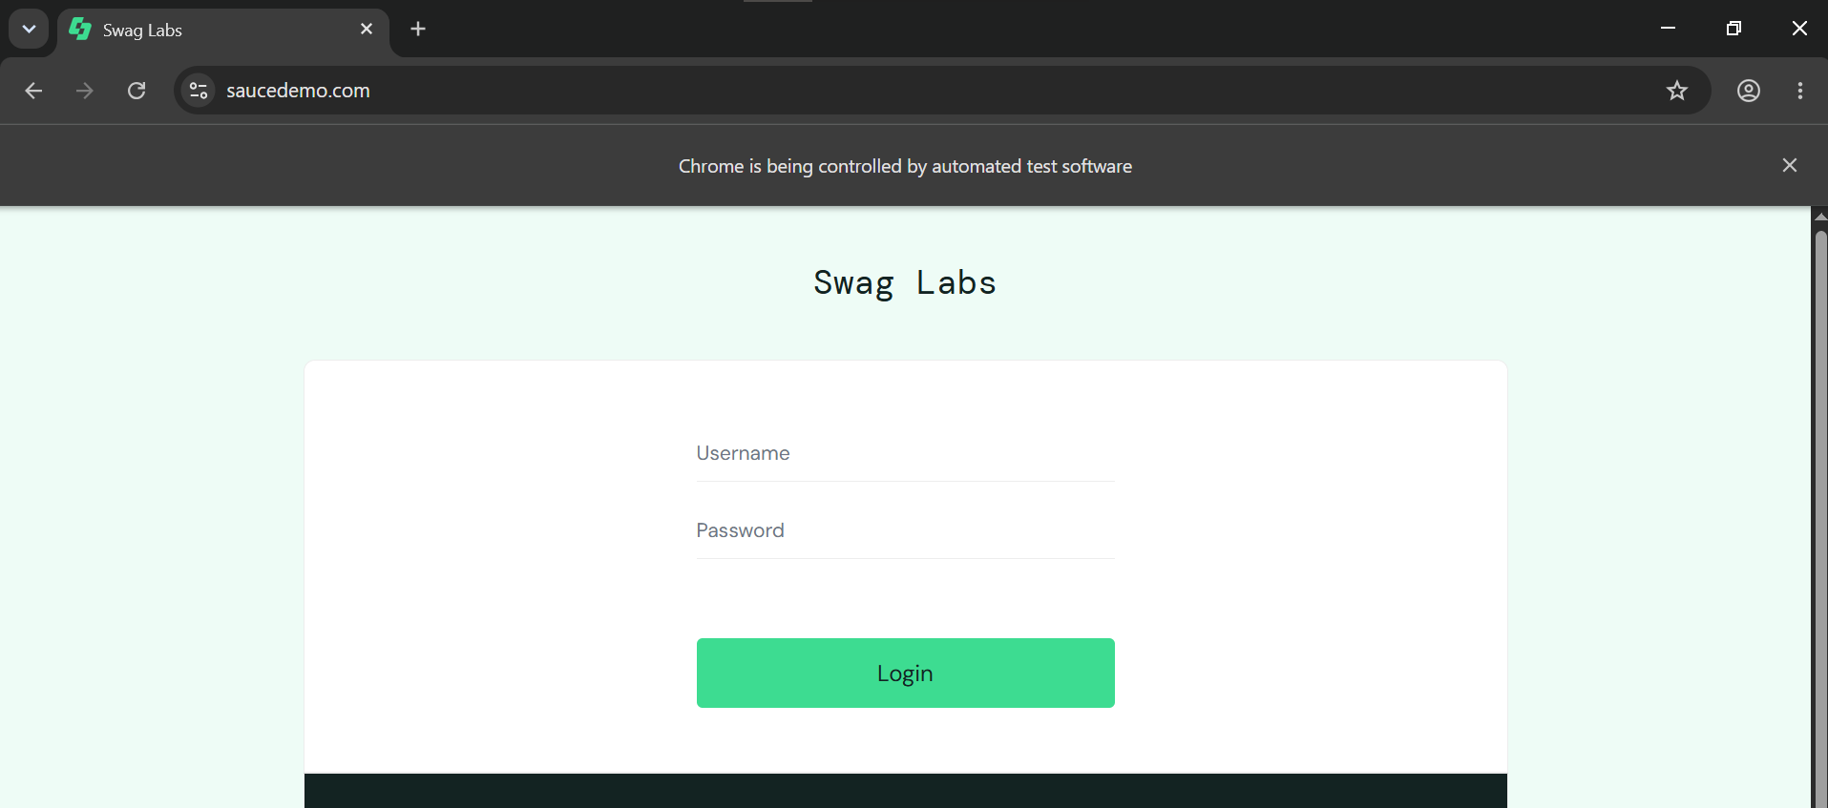

- Scenario ID: SEL02
Scenario
Valid Credentials.
Test Steps
1. Login With valid credentials
2. Observe output

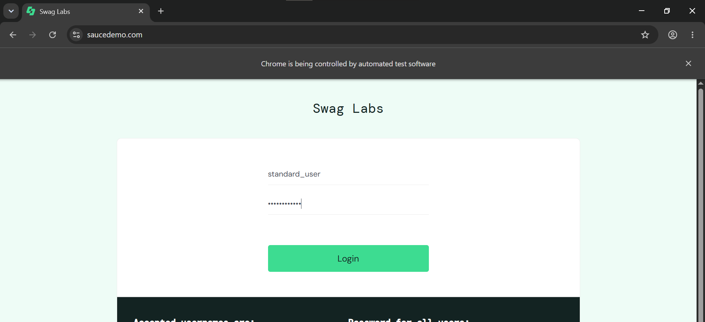

- Scenario ID: SEL03
Scenario
Valid login
Test Steps
1. Click login
2.Observe output
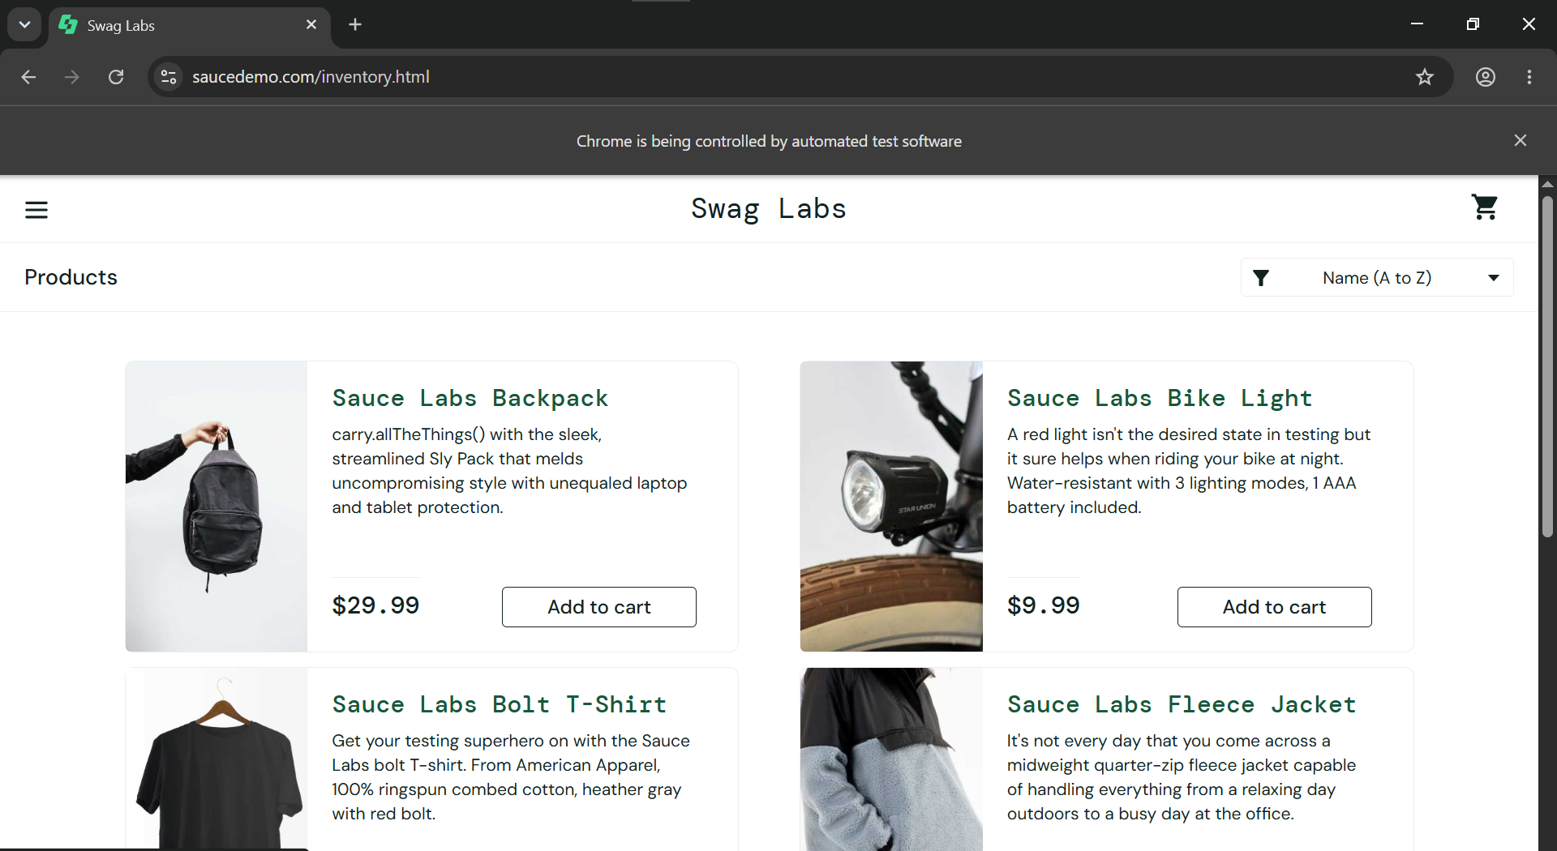

- Scenario ID: SEL04
Scenario
Add product to cart
Test Steps
1. Add product to cart
2. Observe Changes

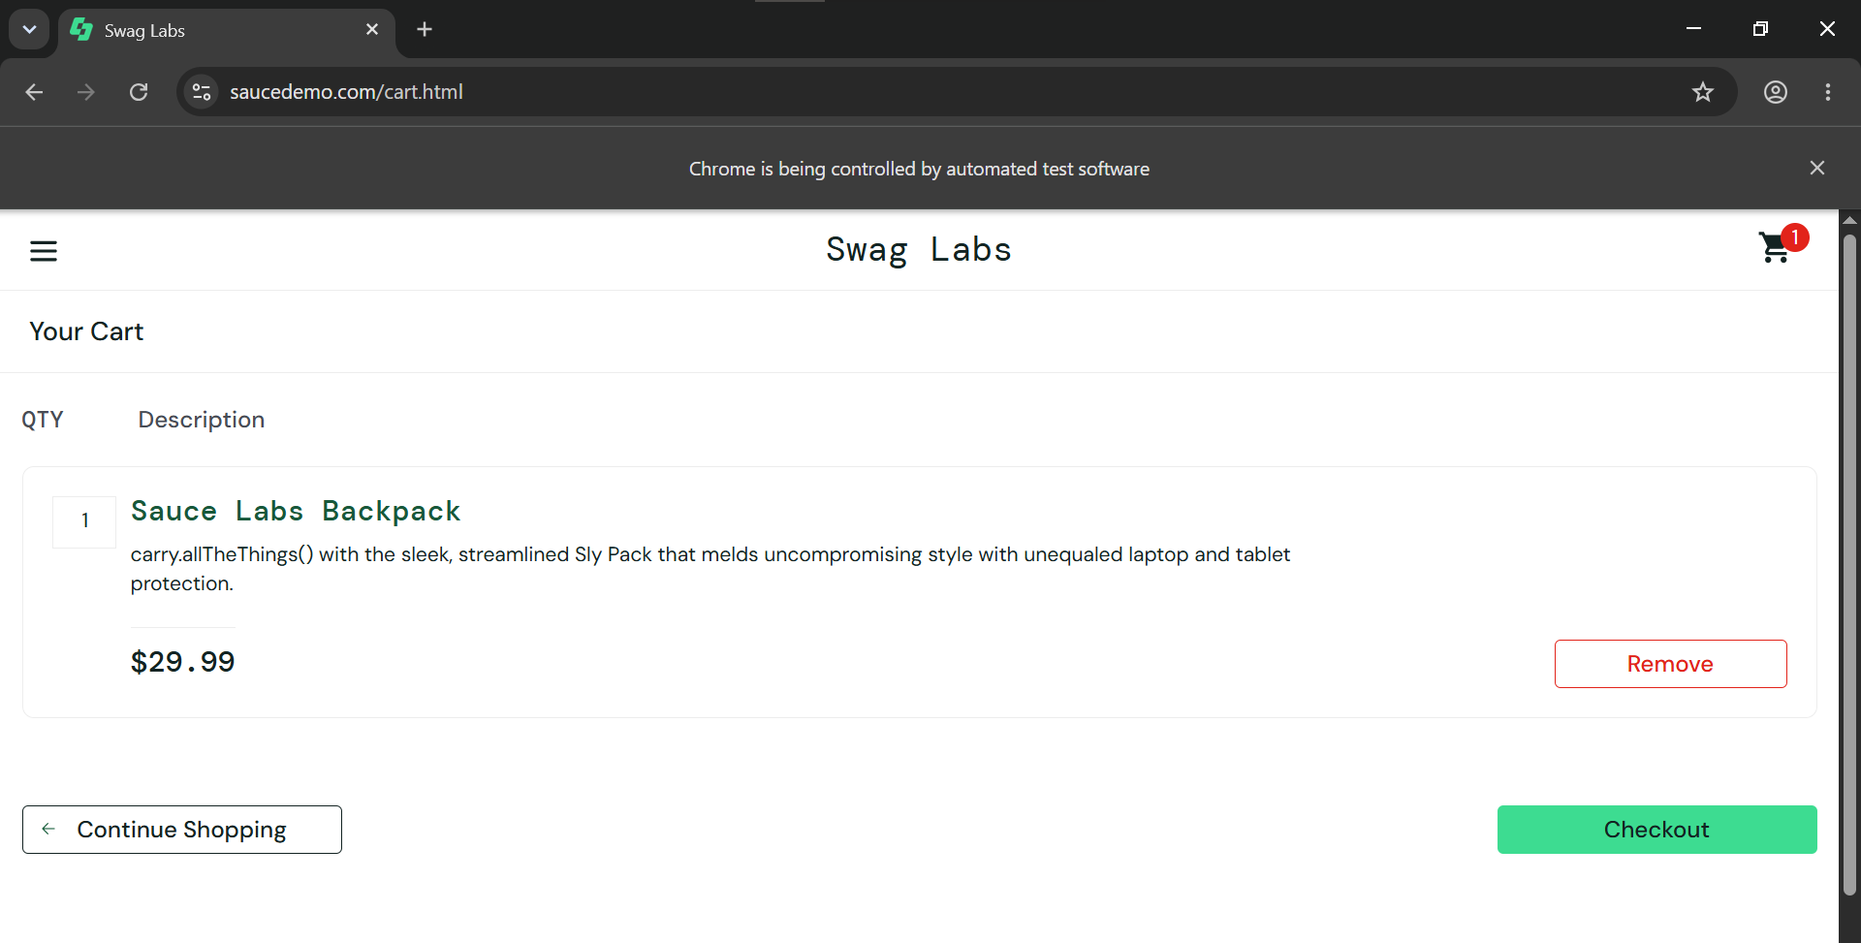

- Scenario : Inspect element
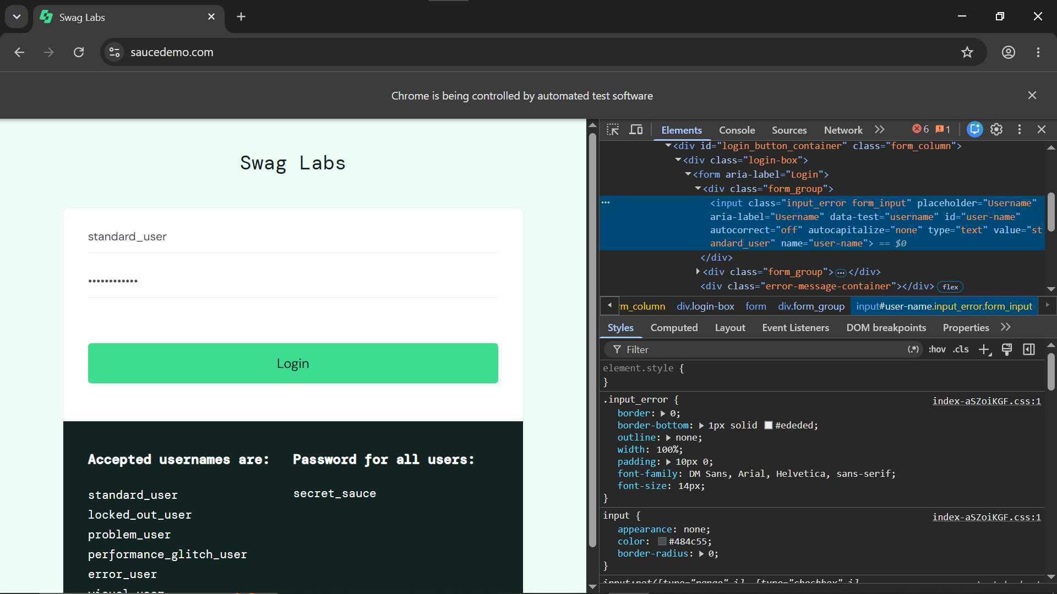

- Code:
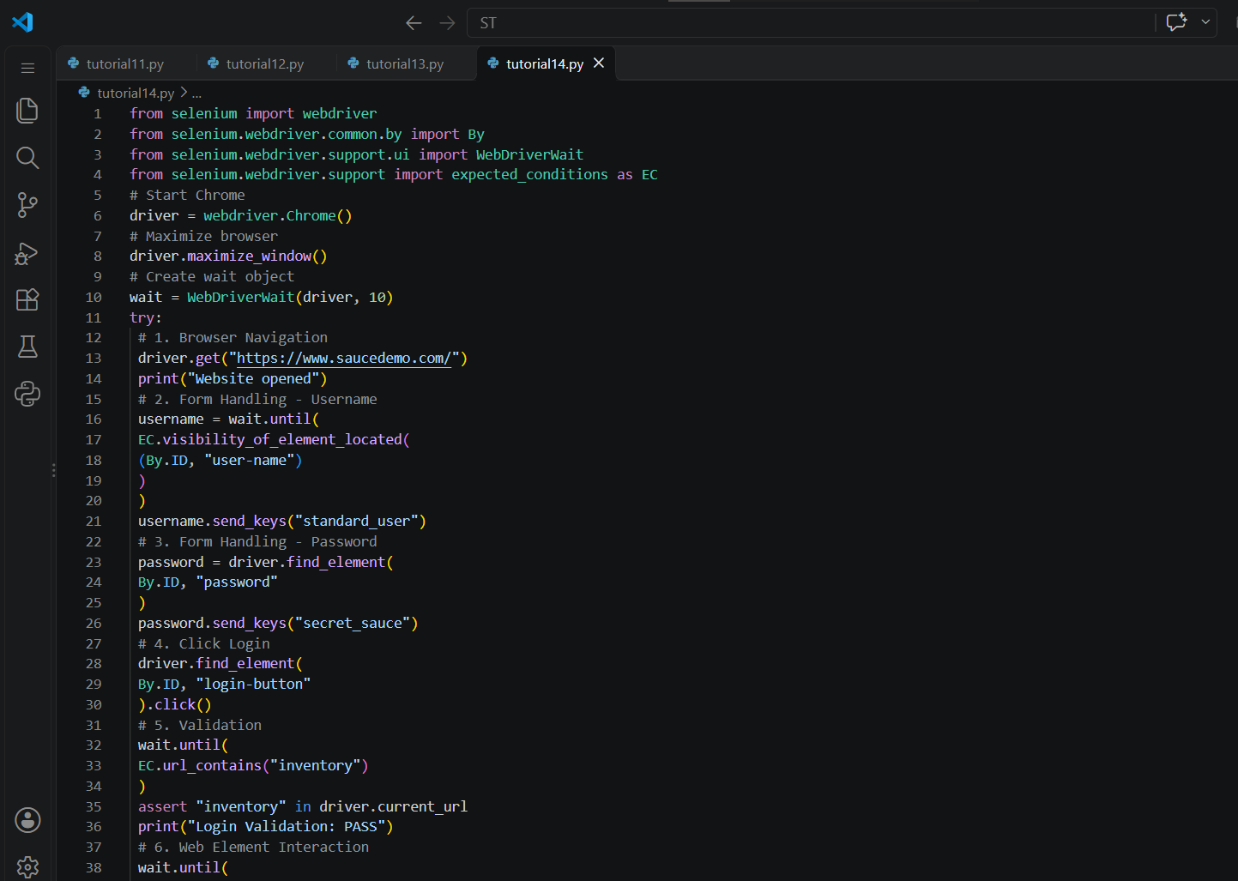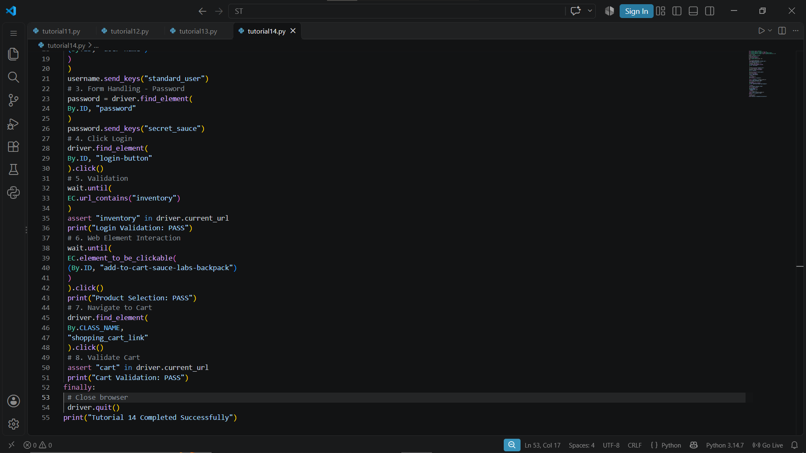

- Console Output:
